

NATIONAL PUBLIC SCHOOL

BANASHANKARI

COMPUTER SCIENCE

INVESTIGATORY PROJECT

CONTROL YOUR SPENDINGS

**Created by:**

Shaunak Saxena

Class 11- B

Roll no. 10

Index

|  |  |  |
| --- | --- | --- |
| **S.no** | **Title** | **Pg no.** |
| 1. | Acknowledgement | 4 |
| 2. | Program code | 5 |
| 3. | Output preview | 7 |

Acknowledgement

# *“Computer Science is a science of abstraction -creating the right model for a problem and devising the appropriate mechanizable techniques to solve it.” — Alfred Aho.*

Firstly, I would like to express my sincere gratitude to our respected principal ma’am, **Mrs. Jayanti Nair** and our Academic director **Ms Grace C.D.** for giving us the opportunity to do this project.

I would also like to extend my gratitude to our computer science teacher, **Ms. Shivshakti ma’am** for her constant guidance and support. Her enthusiastic interest and encouragement has helped me complete this project successfully.

I would like to thank my parents for their continual support throughout this journey.

Finally, I would also like to express my sincere gratitude to my co-creators, **Sai Eeshwar.D** and **Siddhartha Reddy Kayitha** for their constant support and dedication towards our mutual goal.



Certificate

This is to certify that Shaunak Saxena of Grade XI has successfully completed the Computer Investigatory project titled ‘COVID Quarantine Assistance Program’ as prescribed by CBSE for the year 2019-20.

Date: ______________

Signature of Teacher: _________________

Signature of Principal: __________________

Signature of Examiner: __________________

NATIONAL PUBLIC SCHOOL

BANASHANKARI

Program Code

import numpy as np

import matplotlib.pyplot as plt

m=int(input("enter number of months:"))

ob=[]

per=[]

mo=[]

for i in range(m):

z=input("enter month :")

mo.append(z)

e=int(input("number of expenditures:"))

ob.append([ ])

per.append([])

for j in range(e):

a=input("enter title for {}’ expenditure:".format(j+1))

a1=int(input("enter amount spent:"))

print()

ob[-1].append(a)

per[-1].append(a1)

for x in range(m):

objects = ob[x]

y_pos=np.arange(len(objects))

performance=per[x]

plt.bar(y_pos,performance,alpha=0.5,color='black')

plt.xticks(y_pos,objects)

plt.ylabel('amounts spent')

plt.xlabel('titles')

plt.title(mo[x],)

plt.show()

Output preview

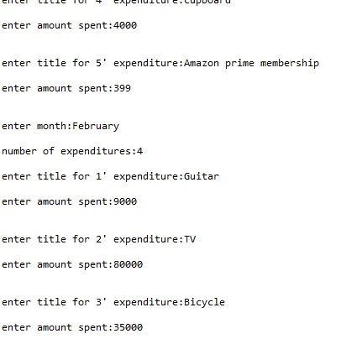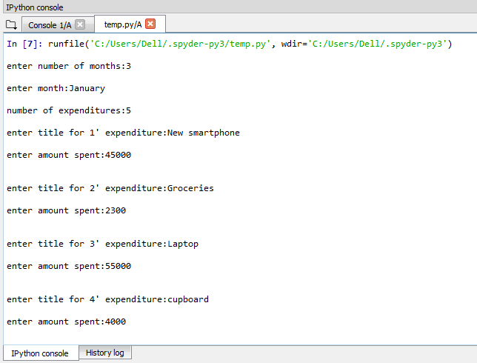

*All output screenshots are taken from Spyder3.

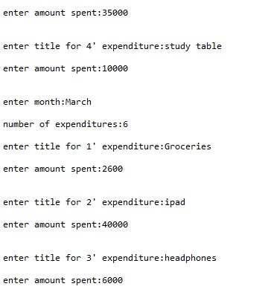

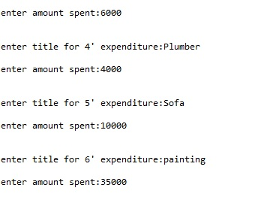

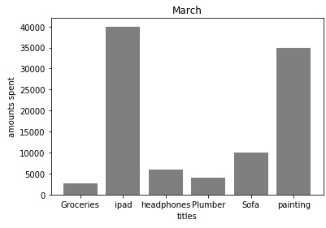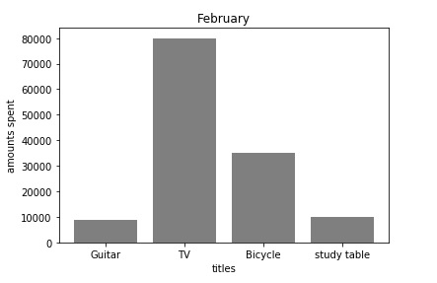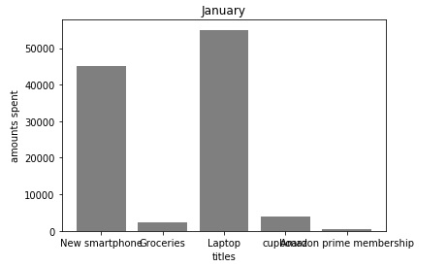

**Cupboard**